**Case Studies & Guesstimates for Healthcare Industries**

The healthcare industry is a cornerstone of society, providing essential services that ensure the well-being and health of populations worldwide. In today's era, its importance has been underscored by the rapid advancements in medical technology and the increasing demand for quality healthcare services. The industry faces numerous challenges, including rising costs, ageing populations, and the need for more efficient patient care.

Data scientists play a pivotal role in addressing these challenges, leveraging their expertise to analyse vast amounts of healthcare data. They help in predicting disease outbreaks, personalising treatment plans, and improving patient outcomes through predictive analytics. Additionally, data scientists optimise hospital operations, enhance diagnostic accuracy with machine learning algorithms, and contribute to the development of new medical treatments and drugs. By harnessing the power of data, they drive innovation, improve efficiency, and ensure the delivery of high-quality healthcare services, making a significant impact on the industry's growth and sustainability.

**PART - I**

**Product Dissection**

**1. Platform Selection**

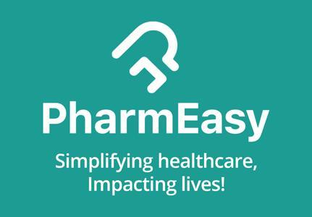

**PharmEasy:** In the rapidly evolving digital healthcare landscape of India, PharmEasy stands out as a leading and transformative platform. Launched in 2015, PharmEasy has redefined the way millions of Indians access healthcare services by integrating technology with essential medical needs. The platform offers a comprehensive suite of services, including doorstep delivery of medicines,

diagnostic test bookings, and online teleconsultations—creating a one-stop digital healthcare ecosystem.

* **Popularity and Market Penetration:** PharmEasy stands out as one of India’s leading HealthTech platforms, with widespread popularity across over 1,000 cities and millions of app downloads. Its strategic merger with MedLife and acquisition of Thyrocare significantly expanded its reach, especially in Tier-II and Tier-III cities, making quality healthcare more accessible to underserved populations.
* **Industry Impact and Role in Public Health**: The platform has had a profound impact on public health delivery in India by streamlining online consultations, diagnostics, and medicine delivery. During the COVID-19 crisis, it played a vital role in ensuring continuity of care, while also promoting digital health literacy and chronic disease management through its integrated services.
* **Relevance, Innovation, and Scalability**: PharmEasy has emerged as a leader in India’s HealthTech space through continuous innovation and a scalable, tech-driven model. By leveraging AI for prescription digitization, smart refills, real-time tracking, and personalized recommendations, it enhances both user experience and health outcomes. Its scalable infrastructure—powered by APIs, cloud technology, and analytics—supports B2C and B2B services alike. Additionally, its SaaS tools and logistics solutions extend its reach to pharmacies, hospitals, and clinics, reinforcing its role in advancing integrated, digital-first healthcare.

**2. Core Features and Functionalities of PharmEasy**

### **Online Medicine Ordering and Home Delivery:** PharmEasy enables users to upload prescriptions or search medicines by name and get them delivered to their doorstep. The platform offers both generic and branded drugs, often at discounted rates.

### **Diagnostic Test Booking:** Users can schedule lab tests and full-body checkups at home from reputed diagnostic labs like Thyrocare. The reports are delivered digitally via the app.

1. **Teleconsultation (Online Doctor Consultations):** PharmEasy provides 24/7 access to licensed doctors across general medicine, dermatology, gynecology, and more. Consultations happen via chat, audio, or video calls.
2. **E-Prescription and Medicine Reminder:** The platform allows doctors to issue e-prescriptions and sends medicine refill reminders based on previous orders or prescriptions.
3. **User-Friendly Mobile App and Web Interface:** With intuitive navigation, order tracking, digital health records, and search optimization, PharmEasy ensures a frictionless user journey.
4. **Subscription-Based Wellness Plans:** PharmEasy offers health packages that include regular diagnostics, consultations, and discounts on medicines for long-term care.
5. **Integrated Health Records and Reports:** The platform stores users’ health records, lab reports, and consultation history in a digital format that is accessible anytime.
6. **Pharma Logistics and B2B Services:** Beyond consumer-facing features, PharmEasy offers B2B SaaS tools and last-mile delivery services for pharmacies and hospitals.

## **Contribution to Platform Success and Engagement**

* **Convenience**: End-to-end healthcare on a single platform reduces the need for multiple apps or in-person visits.
* **Trust**: Integration with certified labs, licensed doctors, and verified drug sourcing builds consumer confidence.
* **Affordability**: Discounts, offers, and bundled wellness plans attract price-sensitive users.
* **Retention**: Features like refill reminders, digital records, and subscription plans improve long-term engagement.

These capabilities collectively position PharmEasy as a leading force in India’s digital healthcare landscape, driving accessibility, innovation, and long-term user trust in an increasingly tech-enabled industry.

### **Real-World Problems Addressed by PharmEasy**

1. **Limited Access to Medicines and Healthcare in Remote Areas  
    Problem:** Many Tier-II and Tier-III cities lack adequate access to pharmacies, diagnostic labs, and healthcare professionals.  
    **PharmEasy’s Solution**: Offers a digital platform for ordering medicines, booking diagnostic tests, and consulting doctors online. Doorstep delivery and home sample collection bridge the urban-rural healthcare gap.
2. **Time Constraints and Mobility Issues  
    Problem:** Elderly, disabled, or busy individuals often find it difficult to visit healthcare facilities.  
    **PharmEasy’s Solution:** Provides online doctor consultations, medicine delivery, and at-home sample collection, ensuring accessibility for users with limited mobility or busy schedules.
3. **High and Unclear Healthcare Costs  
    Problem:** Medical treatments often involve unpredictable and high out-of-pocket expenses.  
    **PharmEasy’s Solution:** Offers discounts of up to 25% on medicines and affordable health check-up packages. Subscription plans and loyalty programs further reduce recurring costs and enhance pricing transparency.
4. **Risk of Counterfeit or Expired Medicines  
    Problem:** Buying from unverified local pharmacies increases the risk of receiving fake or expired products.  
   **PharmEasy’s Solution:** Sources medicines only from certified sellers, implements strict quality checks, and ensures the authenticity of every order.
5. **Lack of Preventive Health Awareness** **Problem:** Preventive care is often neglected, leading to delayed diagnoses.  
    **PharmEasy’s Solution:** Promotes preventive health through full-body check-ups, disease-specific tests, timely reminders, and informative notifications. Collaborations with reputed labs ensure accurate and quick results.
6. **Inconvenience in Booking Diagnostics and Accessing Reports  
    Problem:** Traditional diagnostic labs require physical visits, causing delays and discomfort.  
    **PharmEasy’s Solution:** Enables online booking of lab tests, home sample collection, and access to digital reports through the app, streamlining the diagnostic process.
7. **Fragmented Healthcare Experience  
    Problem:** Users typically need to visit multiple platforms or locations for consultations, tests, and medicines.  
    **PharmEasy’s Solution:** Provides an all-in-one healthcare platform that integrates doctor consultations, medicine ordering, and diagnostics.
8. **Errors in Prescription Handling and Medicine Orders  
    Problem:** Manual processing can lead to order inaccuracies or miscommunication.  
    **PharmEasy’s Solution:** Uses AI and ML to digitize and validate prescriptions, reducing errors and ensuring accurate fulfillment.
9. **Low Medication Adherence and Missed Refills  
    Problem:** Patients often forget to take or refill medications, especially in chronic illness management.  
    **PharmEasy’s Solution:** Offers smart reminders and auto-refill features to promote adherence and consistent treatment.

By solving these issues through digital integration and user-centered design, PharmEasy enhances healthcare delivery efficiency and accessibility across diverse demographics.

**Database Management & Schema Design**

**4. Schema Design**

The PharmEasy schema captures the core functionalities of the platform, including online medicine orders, lab test bookings, doctor consultations, and secure payments. It organizes data into key entities such as users, medicines, orders, prescriptions, lab tests, doctors, and deliveries, with well-defined relationships to support seamless healthcare services. Designed for efficiency, scalability, and data integrity, the schema supports PharmEasy’s goal of providing integrated, tech-driven, and user-friendly healthcare solutions across India.

#### **Key Entities and Attributes:**

**1. Users**

| **Attribute** | **Type** | **Description** |
| --- | --- | --- |
| user_id | INT, Primary Key, Auto Increment | Unique identifier for each user |
| name | VARCHAR(100) | Full name of the user |
| email | VARCHAR(100), Unique | User’s email address, used for login and communication |
| phone | VARCHAR(15), Unique | Contact number for order updates and OTPs |
| password_hash | TEXT | Encrypted user password for login authentication |
| dob | DATE | Date of birth of the user |
| gender | VARCHAR(10) | Gender of the user |
| created_at | TIMESTAMP (default: current time) | Timestamp when the user account was created |

**2. Doctors**

| **Attribute** | **Type** | **Description** |
| --- | --- | --- |
| doctor_id | INT, Primary Key, Auto Increment | Unique ID for each doctor |
| name | VARCHAR(100) | Doctor’s full name |
| specialization | VARCHAR(100) | Field of medicine (e.g., Dermatology, Pediatrics) |
| license_number | VARCHAR(50), Unique | Unique registration/license number |
| phone | VARCHAR(15) | Contact number of the doctor |
| email | VARCHAR(100) | Email address of the doctor |

**3. Addresses**

| **Attribute** | **Type** | **Description** |
| --- | --- | --- |
| address_id | INT, Primary Key, Auto Increment | Unique identifier for each address |
| user_id | INT, Foreign Key → users.user_id | Reference to the user who owns this address |
| address_line | TEXT | Full address text (e.g., street, building info) |
| city | VARCHAR(50) | City of the address. |
| state | VARCHAR(50) | State of the address. |
| pincode | VARCHAR(10) | Area postal code for delivery. |
| is_default | BOOLEAN | Boolean indicating if this is the user’s default address. |

**4. Medicines**

| **Attribute** | **Type** | **Description** |
| --- | --- | --- |
| medicine_id | INT, Primary Key, Auto Increment | Unique ID for each medicine. |
| name | VARCHAR(100) | Name of the medicine. |
| brand | VARCHAR(100) | Brand or manufacturer of the medicine |
| category | VARCHAR(50) | Category/type of medicine (e.g., Antibiotic, Painkiller). |
| price | DECIMAL(10,2) | Retail price of the medicine. |
| stock_quantity | INT | Number of units available in stock. |
| prescription_required | BOOLEAN | Boolean indicating whether a prescription is needed. |
| description | TEXT | Detailed information about the medicine. |

**5. Prescriptions**

| **Attribute** | **Type** | **Description** |
| --- | --- | --- |
| prescription_id | INT, Primary Key, Auto Increment | Unique ID for each uploaded prescription. |
| user_id | INT, Foreign Key → users.user_id | User who uploaded the prescription. |
| uploaded_at | TIMESTAMP | Timestamp when the prescription was uploaded. |
| file_url | TEXT | Location or path to the prescription file. |
| verified | BOOLEAN | Boolean indicating whether the prescription is verified. |
| verified_by | INT, Foreign Key → doctors.doctor_id | Doctor ID of the verifier (if verified). |

**6. Orders**

| **Attribute** | **Type** | **Description** |
| --- | --- | --- |
| order_id | INT, Primary Key, Auto Increment | Unique ID for the order. |
| user_id | INT, Foreign Key → users.user_id | ID of the user who placed the order. |
| order_date | TIMESTAMP | Date and time when the order was placed. |
| status | VARCHAR(30) | Current status of the order (e.g., Placed, Delivered). |
| total_amount | DECIMAL(10,2) | Total value of the order. |
| delivery_address_id | INT, Foreign Key → addresses.address_id | Address where the order will be delivered. |
| prescription_id | INT, Foreign Key → prescriptions.prescription_id (nullable) | Prescription used for the order (if required). |

**7. Order_items**

| **Attribute** | **Type** | **Description** |
| --- | --- | --- |
| order_item_id | INT, Primary Key, Auto Increment | Unique ID for each order item. |
| order_id | INT, Foreign Key → orders.order_id | Reference to the parent order. |
| medicine_id | INT, Foreign Key → medicines.medicine_id | ID of the medicine ordered. |
| quantity | INT | Number of units ordered. |
| price_at_purchase | DECIMAL(10,2) | Price of the medicine at time of order. |

**8. lab_tests**

| **Attribute** | **Type** | **Description** |
| --- | --- | --- |
| test_id | INT, Primary Key, Auto Increment | Unique ID for the lab test. |
| name | VARCHAR(100) | Name of the test (e.g., CBC, Lipid Profile). |
| description | TEXT | Summary of the test's purpose. |
| price | DECIMAL(10,2) | Cost of the test. |
| home_sample_available | BOOLEAN | Indicates if home sample collection is available. |

**9. Test_bookings**

| **Attribute** | **Type** | **Description** |
| --- | --- | --- |
| booking_id | INT, Primary Key, Auto Increment | Unique ID for each test booking. |
| user_id | INT, Foreign Key → users.user_id | User who booked the test. |
| test_id | INT, Foreign Key → lab_tests.test_id | Test being booked. |
| booking_date | DATE | Date the test was booked. |
| appointment_time | DATETIME | Scheduled time for sample collection/test. |
| status | VARCHAR(30) | Booking status (e.g., Scheduled, Completed). |

**10. Payments**

| **Attribute** | **Type** | **Description** |
| --- | --- | --- |
| payment_id | INT, Primary Key, Auto Increment | Unique ID for the payment. |
| order_id | INT, Foreign Key → orders.order_id | Related order for which payment was made. |
| amount | DECIMAL(10,2) | Amount paid. |
| payment_method | VARCHAR(50) | Method used (e.g., UPI, Credit Card, COD). |
| payment_status | VARCHAR(30) | Payment result (e.g., Success, Failed). |
| payment_date | TIMESTAMP | Timestamp when payment occurred. |

**11. Deliveries**

| **Attribute** | **Type** | **Description** |
| --- | --- | --- |
| delivery_id | INT, Primary Key, Auto Increment | Unique delivery record ID. |
| order_id | INT, Foreign Key → orders.order_id | Related order being delivered. |
| delivery_status | VARCHAR(30) | Current delivery status (e.g., Shipped, Delivered). |
| delivery_partner | VARCHAR(50) | Courier service handling the delivery. |
| shipped_date | DATE | Date when order was shipped. |
| delivered_date | DATE | Date when order was delivered. |

**12. Consultations**

| **Attribute** | **Type** | **Description** |
| --- | --- | --- |
| consultation_id | INT, Primary Key, Auto Increment | Unique ID for the consultation. |
| user_id | INT, Foreign Key → users.user_id | ID of the patient booking the consultation. |
| doctor_id | INT, Foreign Key → doctors.doctor_id | ID of the consulting doctor. |
| scheduled_time | DATETIME | Date and time of the consultation. |
| status | VARCHAR(30) | Status of the consultation (e.g., Scheduled, Completed). |
| notes | TEXT | Additional notes or prescriptions provided by the doctor. |

This schema design captures the essential data interactions and relationships within PharmEasy, efficiently supporting its core functionalities such as medicine delivery, lab test bookings, doctor consultations, and secure transactions. It ensures scalability, reliability, and a seamless healthcare experience, contributing to the platform's operational efficiency and user satisfaction.

**5. ER Diagram Creation**

The ER diagram for PharmEasy offers a clear and comprehensive visualization of the platform’s data architecture, mapping out the key entities such as users, medicines, prescriptions, lab tests, orders, and doctor consultations. It elegantly illustrates the relationships and attributes that power PharmEasy’s end-to-end healthcare services—from medicine delivery and diagnostic bookings to teleconsultations and secure payments. This structured representation reveals the interconnected data flow that enables personalized care, operational efficiency, and seamless user experiences. By analyzing this ERD, one can gain deep insights into PharmEasy’s robust and scalable digital healthcare ecosystem.

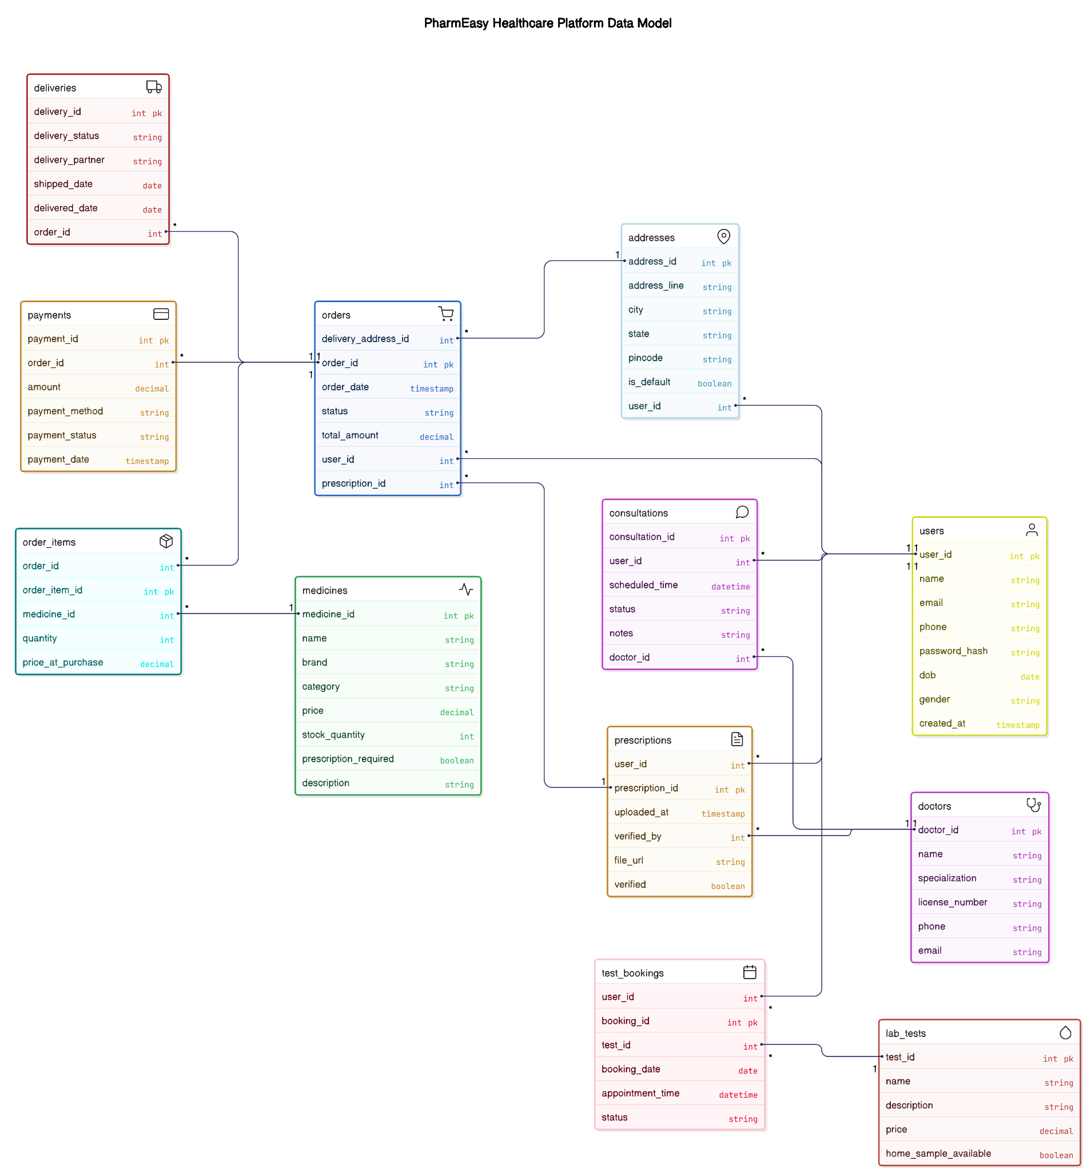

**Case Study: Revenue and Profit Growth Strategies**

1. **Analysing PharmEasy's Current Status**

| **Category** | **Details** |
| --- | --- |
| **Current Financial Data** | **Revenue**: ₹5,664 crore in FY24. |
| **Expenses**: ₹7,254.8 crore in FY24. |
| **Profit/Loss**: Net loss of ₹2,533 crore.  **Profit/Loss Trend**: Reported a 15% drop in revenue, a 19.2% reduction in expenses, and significantly narrowed its net loss by 51% in FY24 compared to FY23 |
| **Sources of Revenue** | **Pharmaceutical and Cosmetic Products – ₹4,880.3 Cr (≈ 67.3%):** Primary revenue from selling prescription drugs, OTC medications, and healthcare products; major expenses relate to sourcing these items. |
| **Diagnostic Services – ₹784.3 Cr (≈ 10.8%):** Revenue from facilitating diagnostic tests through partner labs; expenses include commissions and operational costs. |
| **Teleconsulting – ₹727.9 Cr (≈ 10.0%):** Revenue from online doctor consultations offered via the platform; expenses cover platform support and medical professional fees. |
| **Other Services – ₹862.3 Cr (≈ 11.9%):** Income from delivery, logistics, warehousing, software and hardware leasing, and miscellaneous services; expenses include infrastructure and operational costs. |
| **Analyse Revenue Contribution**  **Top Contributors:**   * Chronic disease patients (diabetes, hypertension) * Combo kits for vitamins + lab tests   **High-Margin Services:**   * Consultations (~30% margin) * Wellness products (20–25% margins) |
| **Sources of Expenses** | **Purchase of Stock-in-Trade** – ₹4,572.8 Cr (≈ 63.0%): Primary expense for acquiring medicines and healthcare products for resale; this includes the cost of sourcing pharmaceutical products. |
| **Employee Benefit Expenses** – ₹699.3 Cr (≈ 9.6%): Salaries, wages, and benefits for PharmEasy’s workforce; a significant reduction from the previous year due to workforce optimization. |
| **Finance Costs** – ₹727.9 Cr (≈ 10.0%): Interest and other borrowing-related expenses; reflecting the cost of financing the company’s operations. |
| **Sales Promotion & Marketing Expenses** – ₹24.4 Cr (≈ 0.43%): Costs related to advertising, influencer campaigns, and promotional offers aimed at acquiring and retaining customers. |
| **Other Expenses** – ₹1,632.4 Cr (≈ 22.5%): Includes various operational costs such as warehousing, logistics, software, hardware leasing, legal, and professional fees, delivery costs, and miscellaneous administrative expenses. |
| **Customer Acquisition & Retention** | **Customer Acquisition Channels** – Digital ads, referral programs, influencer marketing, and television ads: PharmEasy uses a variety of channels to acquire new customers, with digital channels being a key focus. |
| **Effectiveness of Acquisition Channels** – PharmEasy evaluates channel effectiveness by comparing CAC with customer acquisition. Digital channels like social media, SEM, and email marketing typically offer lower CACs, ranging from ₹290 for B2C to ₹1,450 for fintech, making them more efficient and cost-effective. |
| **Retention Rates** – Approximately 70-80%: PharmEasy’s retention rate is driven by personalized communication, loyalty programs, and reliable service. High among chronic care patients (diabetes, hypertension, thyroid). |
| **Churn Analysis (~45%)** – Churn occurs due to delivery delays or product unavailability; PharmEasy reduces churn by improving service reliability and expanding product availability. Non-subscription buyers often drop after the first transaction. |

By analyzing the current status of PharmEasy, including its financial data, revenue sources, expenses, and customer acquisition channels, data science students can develop a comprehensive strategy to increase the company's profit by 25%. Focusing on optimizing expenses, enhancing revenue streams, and improving customer satisfaction and retention will ensure sustainable growth and profitability for PharmEasy. Using data-driven insights at each step will lead to more effective and strategic decision-making.

### 

### **2. Focus Areas to Strengthen PharmEasy’s Growth and Profitability in Healthcare**

| **Internal Management & Operational Efficiency (~8%)** | **Inventory & Procurement Optimization (Waste Management)** | * Implement real-time stock visibility and predictive analytics to reduce expiries and out-of-stock incidents. * Consolidate procurement to negotiate **bulk discounts**; consider direct-from-manufacturer sourcing for generics. |
| --- | --- | --- |
| **Process Automation** | * Leverage **AI and RPA** to automate order verification, prescription validation, inventory sync, and refill reminders. * Use chatbots and IVR systems to handle customer queries and reduce human dependency. |
| **Vendor & Supply Chain Efficiency** | * Renegotiate contracts with diagnostic and pharma vendors for better payment terms and pricing. * Optimize last-mile delivery using **AI route planning**, and consolidate warehouses based on usage patterns. |
| **Employee Productivity & Metrics** | * Introduce training for logistics & support teams. * Track KPIs like average order processing time, error rates, and customer resolution speed. * Introduce **incentive-linked performance programs** |
| **Product & Service Strategy (~4%)** | **High-Margin Product Expansion** | * Launch **wellness kits, home healthcare devices**, and disease-specific bundles (e.g., diabetes/thyroid kits). * Focus on recurring-use items to drive **subscription-based models**. |
| **Product Mix Optimization** | * Phase out slow-moving SKUs based on analytics. * Introduce **combo packs** and preventive care packages to boost AOV and conversion. |
| **Diagnostics & Lab Expansion** | * Scale home sample collection and subscription health checkups. * Partner with local labs for faster turnaround and regional relevance. |
| **Market Reach & Expansion (~5%)** | **Tier-2/Tier-3 Penetration** | * Open **micro-fulfillment centers** and offer services in local languages via the app. * Expand to new geographies based on digital health readiness and unmet needs. |
| **Localization Strategy** | * Offer **regional brands, Ayurveda**, and vernacular services. * Partner with **local pharmacies, labs, and doctors** for trust-building. |
| **B2B Channels & Clinic Partnerships** | * Target **small clinics, corporates**, and hospitals for regular bulk medicine & diagnostic orders. * Provide white-label options or co-branded preventive care packages. |
| **Post-Sales Experience & Retention (~2%)** | **Customer Support Excellence** | * Offer **24/7 multilingual support** via live chat, WhatsApp, and call centers. * Enable post-order prescription uploads and lab test rescheduling support. |
| **Customer Loyalty & Retargeting** | * Launch tiered loyalty program (e.g., Plus Gold/Platinum). * Send personalized follow-ups based on diagnostic history and refill cycles. |
| **Feedback & Self-Service** | * Integrate a **self-help knowledge base** in the app and gather feedback through surveys. |
| **Branding, Trust & Acquisition (~6%)** | **Credibility & Trust Building** | * Highlight pharmacist verification, NABL lab accreditation, and doctor affiliations. * Showcase patient success stories, prescription validation, and real-time doctor chat features. |
| **Digital Awareness, SEO/SEM, Referral Engine & Reviews** | * Invest in **health influencer campaigns**, organic SEO, and paid ads (SEM) to increase app downloads and conversions. * Build a **referral loop** with discounts, free consults, and milestone achievements. * Incentivize reviews and testimonials from satisfied users across platforms. |
| **Community & Partnerships** | * Sponsor marathons, host college health camps, and partner with fitness influencers and insurance players for bundled offers. |

### 

**3. Defining Strategies:**

| **Optimize Expenses** **Goal:** Cut costs while maintaining quality and service speed. | * Negotiate better deals with medicine suppliers  → Get discounts through bulk purchases or early payments * Streamline delivery operations  → Use smart routing tools to reduce fuel and delivery time. * Automate internal processes  → Use AI for prescription reading, order validation, and customer chatbots. * Forecast demand accurately  → Avoid overstocking or Stock Outs using data analytics. * Minimize product waste  → Track expiry dates and move excess stock to areas with higher demand. |
| --- | --- |
| **Enhance Revenue Streams** **Goal:** Earn more through smart product strategy and pricing. | * Cross-sell and upsell health products  → Show related items (e.g., if a user buys diabetes medicine, suggest sugar monitor strips). * Create combo packs or care kits  → Combine medicines + vitamins + health services for higher order value. * Launch subscription plans  → Set up monthly plans for repeat medicines (e.g., BP, thyroid). * Promote diagnostic services  → Offer packages for health checkups, home sample collections. * Use smart/dynamic pricing  → Increase or decrease prices based on local demand, inventory, or season. * Offer tiered pricing in diagnostics  → Customers can choose faster report delivery for an extra fee. |
| **Improve Customer Satisfaction & Retention** **Goal:** Keep customers loyal and coming back. | * Send personalized offers and recommendations  → Based on past orders and health needs. * Enable automatic refill reminders  → Remind users to reorder medicines before they run out. * Introduce loyalty programs  → Give reward points for every purchase and referrals. Offer premium memberships  → Benefits like free delivery, priority lab bookings, and extra discounts * Collect feedback actively  → After each order, ask for ratings and improve based on suggestions * Encourage reviews  → Offer small cashback for writing honest product/lab reviews |

### **Approach Summary (Inside-Out Strategy)**

1. Start with cost optimization  
    → Fix backend inefficiencies first to save money.
2. Improve user experience  
    → Make customers happy and loyal through personalization.
3. Then boost revenue  
    → Introduce new services, bundles, and smart pricing to grow profits.

**PART - II**

**Guesstimate Questions**

**Question 1: Estimate the Customer Acquisition Cost (CAC) for PharmEasy in FY2025, assuming a 50% increase in marketing spend.**

**Objective:** Estimate the Customer Acquisition Cost (CAC) for PharmEasy in FY2025, assuming the company increases its marketing spend by 50% compared to FY2024. The CAC represents how much PharmEasy would spend on marketing to acquire each new customer using Bottom-Up Estimation Approach, specifically leveraging the Cost-Based CAC formula

**Assumptions:**

* PharmEasy’s FY2024 marketing spend was ₹24.4 Cr, as per [Inc42's financial report](https://inc42.com/buzz/pharmeasys-fy24-loss-halves-to-inr-2531-cr/). This reflects a sharp reduction from ₹235 Cr in FY2023, indicating a strong focus on profitability and reduced customer acquisition efforts in FY24.
* For FY2025, we assume PharmEasy increases its marketing spend by 50%, bringing it to ₹36.6 Cr. This reflects a moderate shift towards growth while maintaining cost control.
* Industry estimates for Customer Acquisition Cost (CAC) in Indian e-commerce range between ₹800 and ₹1500 per customer. We use a midpoint of ₹1,000 per new customer, which aligns with industry norms and CRISIL’s commentary on high CAC in e-pharma due to discounts and competition. ([CRISIL](https://www.crisilratings.com/en/home/newsroom/press-releases/2024/12/operating-losses-of-e-pharmacies-seen-falling-below-10percent-next-fiscal.html)&[Gokwik](https://www.gokwik.co/blog/reduce-customer-acquisition-cost?utm_source=chatgpt.com))
* We estimate the number of new customers by dividing the total marketing spend by the assumed CAC, following standard marketing efficiency logic.

**Calculation:**

| **Step** | **Details** | **Calculation** |
| --- | --- | --- |
| Marketing Spend (FY2025) | 50% increase from FY2024 | ₹24.4 Cr × 1.5 = ₹36.6 Cr |
| Assumed CAC | Based on industry benchmark | ₹1,000 per customer |
| New Customers Acquired | Spend ÷ CAC | ₹36.6 Cr ÷ ₹1,000 = 3.66 lakh users |
| Final CAC | Spend ÷ Users | ₹36.6 Cr ÷ 3.66 lakh = ₹1,000 per user |

**Conclusion:** With a projected marketing spend of ₹36.6 Cr in FY2025, PharmEasy is expected to acquire approximately 3.66 lakh new customers, resulting in an estimated Customer Acquisition Cost of ₹1,000, which is consistent with industry standards for Indian e-commerce and e-pharma.

**Question 2: Estimate PharmEasy's FY2025 Logistics Cost Breakdown by City Tier (Tier 1, Tier 2, Tier 3)**

**Objective:** Estimate PharmEasy’s FY2025 logistics (delivery) cost by city tier, using known business metrics and industry data. The goal is to project total shipping orders by Tier-1/2/3 and multiply by a per-order delivery cost that rises with remoteness using Bottom-Up Cost Modeling by Segmentation Approach.

**Assumptions:**

1. **FY2025 Revenue Estimate:**

* FY2024 revenue: ₹5,664 crore
* Assuming 10% growth: FY2025 revenue ≈ ₹6,230 crore
* Source: [Economic Times](https://m.economictimes.com/tech/technology/pharmeasy-halves-fy24-loss-to-rs-2533-crore-revenue-dips-15-to-rs-5664-crore/articleshow/115521544.cms)

1. **Average Order Value (AOV):**

* *Average Order Value (AOV):* PharmEasy’s AOV was ₹1,300–1,900 in April 2023; we take ₹1,600.
* Source: ​[m.economictimes.com](https://m.economictimes.com/tech/technology/pharmeasy-logs-first-ebitda-profit-of-rs-14-crore-in-april-restarts-funding-talks/articleshow/100233695.cms#:~:text=PharmEasy%E2%80%99s%20average%20order%20value%20,in%20turning%20around%20its%20finances)

1. **Total Orders in FY2025:**

* Total orders ≈ ₹6,230 crore / ₹1,600 ≈ 39 million orders

1. **Order Distribution by Tier:**

* Tier-1: 37% , Orders: 39 million × 37% = 14.43 million
* Tier-2: 21% , Orders: 39 million × 21% = 8.19 million
* Tier-3: 42% , Orders: 39 million × 42% = 16.38 million
* Source: [Bain & Company](https://www.bain.com/insights/how-india-shops-online-2025/), [globenewswire.com](https://www.globenewswire.com/news-release/2023/11/24/2785662/28124/en/India-Online-Retail-Market-Report-2023-2028-Tier-3-and-Tier-2-Cities-Lead-the-Surge-in-E-commerce-Market-Share.html#:~:text=cities%20witnessed%20an%20upswing%2C%20escalating,in%202022), [nagrika.org](https://www.nagrika.org/nagrikaspeaks/ecommerce-small-cities#:~:text=MSMEs%20have%20benefited%20from%20digital,tier%202%20and%203%20cities), [businesstoday.in](https://www.businesstoday.in/latest/corporate/story/e-commerce-booming-in-indias-tier-2-and-tier-3-cities-says-amazon-indias-vivek-somareddy-401069-2023-10-06#:~:text=E,in%20the%20last%20two%20years)

1. **Logistics Cost per Order:**

* Tier-1: ₹40 (last-mile) + ₹10 (packaging) + ₹40 (Fulfillment & Processing Costs) = ₹90

**Note:** Fulfillment & Processing Costs = Warehousing & Storage + Fulfillment Ops + Tech & Ops Overhead + Returns/Failures

* Tier-2: ₹45 (last-mile) + ₹10 (packaging) + ₹45 (Fulfillment & Processing Costs) = ₹100
* Tier-3: ₹50 (last-mile) + ₹10 (packaging) + ₹50 (Fulfillment & Processing Costs) = ₹110
* Source: [GLG Insights – Indian E-commerce Logistics](https://glginsights.com/articles/analyzing-the-indian-e-commerce-logistics-market/), [Shiprocket Report 2023](https://www.shiprocket.in/blog/logistics-challenges-ecommerce-india/), [WareIQ Blog](https://www.wareiq.com/blog/ecommerce-packaging-costs/)

**Calculations:**

| **Tier** | **Orders** | **Per-Order Cost (₹)** | **Annual Logistics Cost (₹ Cr)** |
| --- | --- | --- | --- |
| Tier-1 | 14.43 M | ₹90 | ₹1298.7 Cr |
| Tier-2 | 8.19 M | ₹100 | ₹81.9 Cr |
| Tier-3 | 16.38 M | ₹110 | ₹180.18 Cr |
| Total | 39 M | Weighted avg ~₹102 | ₹391.95 Cr |

**Conclusion:** PharmEasy’s estimated logistics cost for FY2025 is approximately ₹392 crore, with the highest burden in Tier-3 cities due to greater delivery complexity. The weighted average cost per order is ~₹102, reflecting costlier last-mile operations in non-metro regions.

**Question 3: Churn Rate and Revenue Impact in India FY 2025**

**Objective:** Estimate PharmEasy’s annual customer churn rate and quantify the revenue at risk due to churn in FY2025. Churn is defined as the percentage of customers lost over a given period, and understanding this metric is crucial for assessing the company's growth and retention strategies using top-down approach.

**Assumptions:**

* According to a Times of India article, PharmEasy’s retention rate was reported at approximately 80% in Tier-1 cities and 72% in Tier-2/3 cities during the post-lockdown period.([Times of India](https://timesofindia.indiatimes.com))
* Churn is calculated as the inverse of retention (i.e., Churn = 100% – Retention). This gives an estimated churn rate of 20% in Tier-1 and 28% in Tier-2/3 cities.
* Recent industry analyses indicate a significant shift in e-commerce demand towards smaller towns and cities. A report by Unicommerce highlights that Tier-2 and Tier-3 cities accounted for nearly 63% of total e-commerce orders in 2022, growing at a faster rate compared to Tier-1 markets. Considering this trend, it's reasonable to assume that PharmEasy's revenue distribution is approximately 60% from Tier-2/3 cities and 40% from Tier-1 cities.**(**[**New Minute**](https://www.thenewsminute.com/atom/tier-2-cities-smaller-towns-now-contribute-66-e-commerce-demand-india-report-131315?utm_source=chatgpt.com)**),(**[**Mint**](https://www.livemint.com/companies/news/tier-2-3-regions-grab-a-larger-pie-of-e-com-market-11671380417276.html?utm_source=chatgpt.com)**)**
* PharmEasy reported ₹5,664 crore in operational revenue for FY2024, as per recent financial disclosures. ([Economic Times – FY24 Report](https://m.economictimes.com/tech/technology/pharmeasy-halves-fy24-loss-to-rs-2533-crore-revenue-dips-15-to-rs-5664-crore/articleshow/115521544.cms))**.** Assuming a modest 10% revenue growth in FY2025 (conservative estimate given their reduced marketing spend and cost-cutting measures), the projected revenue is ₹6,230 crore.([Inc42](https://inc42.com/))

**Calculation:**

| **Metric** | **Tier-1 Cities** | **Tier-2/3 Cities** | **Notes** |
| --- | --- | --- | --- |
| Customer Retention Rate | 80% | 72% | Based on Times of India report |
| Customer Churn Rate | 20% | 28% | Calculated as 100% - retention rate |
| Revenue Contribution Assumption | 70% | 30% | Assumed distribution due to lack of specific data |
| Weighted Churn Rate (Overall) | - | - | (0.7 × 20%) + (0.3 × 28%) = 22.4% |
| FY2025 Projected Revenue (₹ Cr) | - | - | ₹6,230 crore (10% growth over FY2024) |
| Estimated Revenue at Risk (₹ Cr) | - | - | 22.4% of ₹6,230 Cr ≈ ₹1,396 Cr |

**Conclusion:** PharmEasy’s estimated churn rate for FY2025 is 22.4%, placing approximately ₹1,396 crore of revenue at risk. This reflects lower retention in Tier-2/3 cities, which now drive a majority of demand and pose a significant challenge to sustainable growth.

**Question 4: Estimate PharmEasy’s total medicine sales revenue (B2C + B2B) in Mumbai for FY2025**

**Objective:** Estimate PharmEasy’s total medicine sales revenue (B2C + B2B) in Mumbai for FY2025 using a Bottom-Up Market Sizing Approach.

**Assumptions:**

* Mumbai population (2025): ≈22.1 million​ ([worldpopulationreview.com](https://worldpopulationreview.com/cities/india/mumbai#:~:text=Mumbai%27s%202025%20population%20is%20now,population%20in%20addition%20to%20adjacent)). We use the UN-based projection (urban agglomeration) for 2025.
* Internet/smartphone penetration: India’s internet penetration was ~48.7% in 2023 (​[datareportal.com](https://datareportal.com/reports/digital-2023-india#:~:text=,7%C2%A0percent)). Given Mumbai’s urban profile, we assume ≈80% of its population have internet access.
* Online pharmacy adoption: We assume 20% of internet users in Mumbai purchase medicines online (reflecting growing e-commerce and COVID-driven adoption). ([The rise of E-pharmacy in India: Benefits, challenges, and the road ahead](https://journals.lww.com/iphr/fulltext/2022/54040/the_rise_of_e_pharmacy_in_india__benefits%2C.7.aspx))
* PharmEasy market share: As a leading e-pharmacy, assume PharmEasy captures ≈30% of Mumbai’s online medicine market. ([Economic Times](https://economictimes.indiatimes.com/tech/startups/1mg-overtakes-pharmeasy-in-market-share-in-top-order-change/articleshow/105242460.cms?from=mdr))
* Annual spend per user (B2C): We assume an average PharmEasy customer in Mumbai spends ₹6,000/year on medicines via the platform (~₹500/month). ([redseer](https://redseer.com/newsletters/indian-e-pharma-a-promising-vertical-led-market/))
* B2B contribution: PharmEasy also serves corporate/wholesale clients. We assume B2B medicine sales are about 10% of its B2C medicine revenue in Mumbai ([Unlisted zone](https://unlistedzone.com/comprehensive-report-on-pharmeasys-fy24-financial-performance)).
* FY2024 reference: For context, PharmEasy’s total medicine sales in FY2024 (India-wide) were ₹5,008 Cr (​[m.economictimes.com](https://m.economictimes.com/tech/technology/pharmeasy-halves-fy24-loss-to-rs-2533-crore-revenue-dips-15-to-rs-5664-crore/articleshow/115521544.cms#:~:text=Sales%20of%20medicines%20,stood%20at%20Rs%20652%20crore)). This anchors the scale but is not directly used in the bottom-up calc.

**Calculation:**

| **Step** | **Calculation** |
| --- | --- |
| Mumbai population (2025) | 22.1 million |
| Internet users in Mumbai – Assume 80% penetration | 22.1M × 0.80 = 17.7 million |
| Online medicine users (total) – Assume 20% of internet users buy medicines online. | 17.7M × 0.20 = 3.54 million |
| PharmEasy B2C customers (annual) – Assume PharmEasy’s share of online market is 30%. | 3.54M × 0.30 = 1.06 million |
| Average spend per PharmEasy B2C user – Assumed ₹6,000/year per user. | – |
| PharmEasy B2C revenue (FY2025, Mumbai) – Multiply customers by per-user spend. | 1.06M × ₹6,000 = ₹6,360 million (≈₹636 crore) |
| PharmEasy B2B revenue (FY2025, Mumbai) – Assume B2B adds 10% on top of B2C revenue. | ₹636 Cr × 0.10 = ₹63.6 Cr |
| Total medicine revenue (FY2025, Mumbai) – Sum of B2C and B2B. | ₹636 Cr + ₹63.6 Cr ≈ ₹700 Cr |

**Conclusion:** PharmEasy’s estimated total medicine sales in Mumbai for FY2025 is on the order of ₹700 crore (B2C + B2B combined), under the above assumptions.

**Question 5: Estimate If PharmEasy increases its marketing spend by 50%, estimate the potential increase in market share or revenue in the medicine and diagnostics segment.**

**OBJECTIVE:** To estimate the potential increase in PharmEasy’s revenue and market share in the online medicine and diagnostics segment for FY2025 if the company increases its marketing spend by 50% from FY2024 levels. Using top-down elasticity approach, assuming a linear relationship between marketing spend and revenue growth.

**ASSUMPTIONS:**

* PharmEasy's total revenue in FY2024 was ₹5,664 crore, with ₹5,008 crore from medicines and ₹652 crore from diagnostics and other services.([Economic Times](https://m.economictimes.com/tech/technology/pharmeasy-halves-fy24-loss-to-rs-2533-crore-revenue-dips-15-to-rs-5664-crore/articleshow/115521544.cms))
* Marketing expenditure in FY2024 was ₹24.4 crore, significantly reduced from ₹235 crore in FY2023.([Inc42](https://inc42.com/buzz/pharmeasys-fy24-loss-halves-to-inr-2531-cr/?utm_source=chatgpt.com))
* PharmEasy plans to increase marketing spend by 50%, raising it to ₹36.6 crore in FY2025.
* The Indian e-pharmacy market is projected to reach ₹33,000–₹35,000 crore by FY2025, growing at a CAGR of approximately 22%. The online diagnostics market is estimated to reach around ₹4,000 crore in FY2025, assuming a conservative 15% annual growth rate. Combining both segments, the total addressable market is estimated to be ₹37,000 crore for FY2025.([CAGR](https://www.researchandmarkets.com/reports/5690662/e-pharmacy-market-in-india-2022-2027?srsltid=AfmBOorrtaxEnLfM_Z8Ha5bok2oVjk4nDQtLIVLBOmRoh8aTVFHBywpF&utm_source=chatgpt.com)), ([Linkedin](https://www.linkedin.com/pulse/indian-epharmacy-market-2025-deep-dive-opportunities-rise-shivam-2nqkc/))
* We assume a proportional relationship between marketing spend and revenue growth—i.e., a 50% increase in marketing spend could drive a 50% increase in revenue.

**Calculation:**

| **Metric** | **Value** |
| --- | --- |
| FY2024 Revenue (Medicine + Diagnostics) | ₹5,664 crore |
| Marketing Spend in FY2024 | ₹24.4 crore |
| Marketing Spend in FY2025 (50% Increase) | ₹36.6 crore |
| Estimated Revenue Increase (Assuming 1:1 ratio with marketing spend) | ₹2,832 crore (50% of ₹5,664 crore) |
| Projected Revenue in FY2025 | ₹8,496 crore |
| Total Market Size in FY2025 (Estimated) | ₹37,000 crore |
| Projected Market Share in FY2025 | (₹8,496 / ₹37,000) × 100 = 22.96% |
| Current Market Share (Sep 2023) | 15% |
| Estimated Gain in Market Share | ~8 percentage points |

**Conclusion:** If PharmEasy increases its marketing spend by 50%, and assuming a proportional return on investment:

* Its revenue could rise by ₹2,832 crore, reaching ₹8,496 crore in FY2025.
* Its market share could increase from 15% to nearly 23%.
* This guesstimate assumes linear growth, which in reality may vary due to competition, saturation, and operational factors.

**Question 6: PharmEasy Diagnostics Revenue Estimate (Delhi, FY2025)**

**Objective:** Estimate PharmEasy’s total diagnostic test revenue (B2C + B2B) in Delhi for FY2025 using a bottom-up market-sizing approach.

**Assumptions:**

* Delhi population (2025) – Approximately 34.7 million (metro/urban area)​ ([macrotrends.net](https://www.macrotrends.net/global-metrics/cities/21228/delhi/population#:~:text=,increase%20from%202024)).
* Diagnostic tests per person per year – India saw ~894 million lab tests in FY2022 (​[researchnester.com](https://www.researchnester.com/reports/laboratory-information-systems-market/4236#:~:text=services%20boosts%20the%20market%20growth,conducted%20in%20laboratories%20across%20India)) (~0.64 tests/person nationally). Urban centers tend to have higher healthcare usage; we assume ~1 test/person/year in Delhi.
* Online diagnostics penetration (2025) – With rising digital health adoption (e.g. telemedicine making home diagnostics more accessible​ ([nsearchives.nseindia.com](https://nsearchives.nseindia.com/emerge/corporates/content/Registration_27122024222441_DRHPAvience.pdf#:~:text=Furthermore%2C%20technological%20advancement%20has%20played,areas%20or%20have%20restricted%20mobility)), assume ~10% of diagnostic tests are booked via online platforms by FY2025.
* PharmEasy market share (online diagnostics, Delhi) – RedSeer reports PharmEasy’s share of the online healthcare GMV fell to ~15% by late 2023​ ([financialexpress.com](https://www.financialexpress.com/business/healthcare-pharmeasy-sees-92-cut-in-valuation-at-458-million-3600802/#:~:text=Market%20dynamics%20in%20the%20sector,18)). We assume PharmEasy holds ~15% of Delhi’s online diagnostics orders.
* Average price per diagnostic test – Tests range from very cheap (₹160+) to expensive (₹31,000+)​ ([nsearchives.nseindia.com](https://nsearchives.nseindia.com/emerge/corporates/content/Registration_27122024222441_DRHPAvience.pdf#:~:text=with%20X,Competitiveness%20of%20Market%20Players)). We assume an average selling price ~₹1,000 per test (≈$12).
* B2B (corporate) contribution – In absence of public data, assume ~20% of PharmEasy’s diagnostic volumes come from B2B channels (e.g. corporate or institutional tie-ups), with the rest (80%) from B2C consumers.

**Calculation:**

| **Step** | **Calculation** |
| --- | --- |
| Delhi population (2025 projection) | 34.7 million​ |
| Annual diagnostic tests per person | Assumed 1 test/year |
| Total annual diagnostic tests (Delhi) | 34.7 M × 1 = 34.7 million tests |
| Online diagnostics penetration | Assumed 10% of all tests |
| Online diagnostic tests (Delhi) | 34.7 M × 10% = 3.47 million tests |
| PharmEasy’s share of online tests | ~15%​ ([financialexpress.com](https://www.financialexpress.com/business/healthcare-pharmeasy-sees-92-cut-in-valuation-at-458-million-3600802/#:~:text=Market%20dynamics%20in%20the%20sector,18)) |
| PharmEasy B2C diagnostic tests | 3.47 M × 15% = 0.52 million tests |
| PharmEasy B2B diagnostic tests | (Assuming 20% of total) ≈ 0.13 million tests |
| Total PharmEasy diagnostic tests | 0.52 M + 0.13 M = 0.65 million tests |
| Average price per test | Assumed ₹1,000/test​ |
| PharmEasy B2C diagnostics revenue | 0.52 M × ₹1,000 = ₹520 million |
| PharmEasy B2B diagnostics revenue | 0.13 M × ₹1,000 = ₹130 million |
| Total PharmEasy diagnostics revenue (FY2025) | ₹650 million (≈₹65.0 crore) |

**Conclusion:** PharmEasy is estimated to generate ₹65 crore in diagnostic test revenue in Delhi for FY2025, driven by rising digital adoption, ~10% online diagnostics penetration, and its ~15% market share in the segment.

**PART - III**

**Scenario Based Questions**

#### **Scenario 1:**

PharmEasy is one of India’s leading e-pharmacy platforms, offering doorstep delivery of prescription and over-the-counter medicines. A significant portion of its customer base consists of individuals with chronic health conditions such as diabetes, hypertension, and thyroid disorders, who require recurring monthly medication refills. To better understand and improve customer retention, PharmEasy is conducting a cohort retention analysis, grouping users by the month of their first medicine purchase.

**Question 1**: How would you conduct a cohort retention analysis to track monthly repeat medicine purchases by users who placed their first order in different months? What key metrics would you use to evaluate customer retention and engagement over time?

Ans:

**Cohort Retention Analysis Report – PharmEasy (**[**Colab Link**](https://colab.research.google.com/drive/1zWO_opF3absmZyoGEyVmLU1e_ieN1aSA?usp=sharing)**)**

#### **Objective:**

#### The purpose of this analysis is to evaluate customer retention trends at PharmEasy by examining how often users reorder medications after their initial purchase. This is especially critical for customers with chronic conditions requiring regular refills. The goal is to assess customer engagement and identify drop-offs in retention to inform strategies for improving long-term user loyalty.

#### **Methodology**

#### **Data Used: The dataset contains 3987 rows and three columns – user_id, signup_date, and activity_date. Each row represents a user's medicine purchase in a given month.**

#### **Cohort Definition: Users were grouped by the month of their first purchase (signup_month). Each cohort was tracked monthly to determine repeat activity in subsequent months (activity_month).**

#### **Cohort Index Calculation: We calculated the number of months since signup (cohort_index) to track how long users continued making purchases after joining.**

#### **Retention Metric:**

#### **Retention rate = (Number of unique users active in a given month / Number of users in the cohort’s signup month ​) × 100**

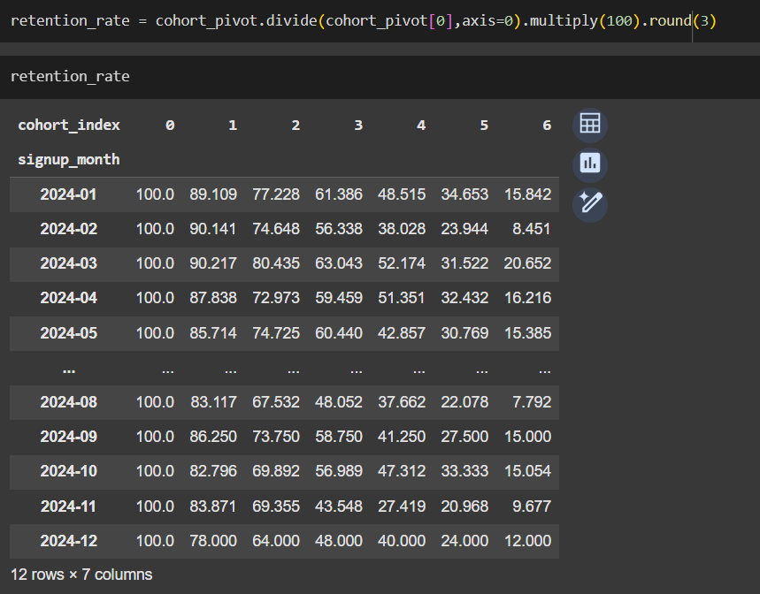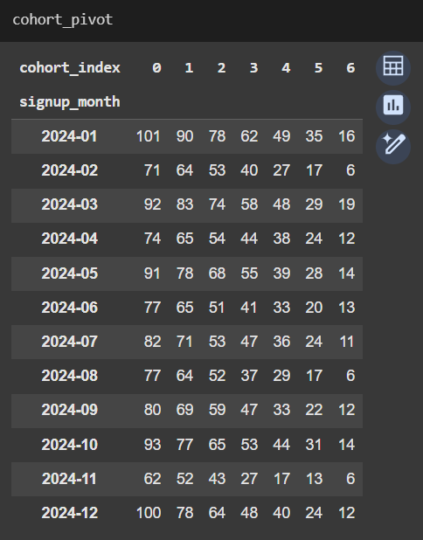

#### 

#### 

#### **Visualization: A heatmap was used to display retention percentages over time for each monthly cohort.each monthly cohort.**

#### 

**Average churn trend:**

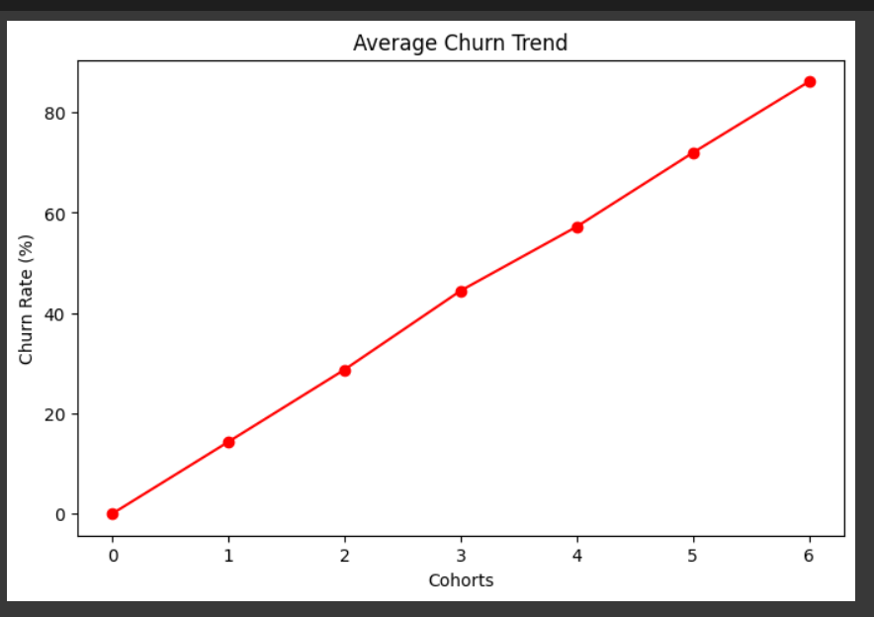

#### **Key Findings**

#### **Strong Initial Engagement:** Across cohorts, nearly 100% of users are active in their signup month, which confirms successful initial conversions.

#### **Consistent Month-1 Retention:** The retention after one month is generally high (e.g., 83–90%), indicating many users make at least one repeat purchase.

#### **Drop after Second Month:** A significant drop is observed from Month 2 onwards, with retention dropping below 60% for most cohorts. By Month 6, retention is typically below 20%, showing steep disengagement.

* **Core Loyal Segment:** A small subset of users continues to order for 4+ months, forming the core loyal base.

#### **Best Performing Cohorts:** Cohorts from **March and April 2024** maintain relatively stronger retention (e.g., ~20% by Month 6), possibly reflecting seasonal or campaign-related influences.

#### **Business Implications**

#### **Low Customer Lifetime Value (CLTV):** The sharp decline in repeat purchases after Month 2 indicates that many users are not converting into long-term customers, especially those with chronic medication needs.

#### **Revenue Loss from Missed Recurring Orders:** Poor retention reduces PharmEasy’s ability to capture consistent, high-margin revenue from monthly refills — a key growth area for e-pharmacies.

#### **High Acquisition Cost Inefficiency:** Marketing and onboarding efforts are underutilized if customers churn early, driving up customer acquisition costs (CAC) without sufficient ROI.

#### **Gaps in Engagement Strategy:** The drop-off suggests weaknesses in post-purchase engagement, such as lack of timely reminders, loyalty incentives, or personalized communication.

#### **Conclusion**

#### Cohort retention analysis reveals that while PharmEasy has strong initial user engagement, it struggles to retain users long-term. By implementing targeted retention strategies focused on recurring needs and user convenience, the platform can boost lifetime value and strengthen customer loyalty.

**Question 2**: If the analysis reveals a significant drop in repeat medicine orders after the second month, what could be the possible reasons for this decline? What strategies could PharmEasy implement to improve medicine order retention among these users?

Ans:

* **Possible Reasons for Decline in Repeat Medicine Orders After Second Month:**

1. **Acute vs. Chronic Use:** Many users may order medicine for short-term illnesses (e.g., cold, infection) rather than chronic conditions, leading to no need for monthly refills.
2. **Lack of Refill Reminders:** Users may forget or delay placing follow-up orders without timely notifications or refill prompts.
3. **User Experience Issues:** Pain points such as poor delivery experience, app usability issues, or product unavailability could discourage repeat purchases.
4. **Pricing & Discounts:** First-time offers may attract users initially, but lack of ongoing incentives could reduce motivation for repeat orders.
5. **Trust & Satisfaction:** If the initial experience didn’t meet expectations, users might switch to offline pharmacies or competitors.

* **Strategies to Improve Medicine Order Retention:**

#### **Auto-Refill Subscriptions for Chronic Users**

#### **Why?** Users with chronic conditions (e.g., diabetes, hypertension) often forget monthly orders or find it inconvenient to reorder manually. **Solution:**

#### Introduce an **auto-refill subscription option** with flexible delivery dates.

#### Allow users to set medicine schedules based on prescription timelines.

#### Include options to modify or pause orders as needed. **Example:** “Running low on your diabetes meds? Your next refill will arrive on May 5 — no need to reorder!”

#### **Personalized Refill Reminders & Nudges**

#### **Why?** Users may drop off simply because they forgot or didn’t get a timely reminder. **Solution:**

#### Use purchase history to send **smart reminders** via WhatsApp, SMS, or app push.

#### Personalize messages with medicine names and refill dates. **Example:** “Hi Riya, it's time to refill your Thyronorm 50mcg — tap here to reorder instantly!”

#### **Second & Third Month Incentive Offers**

#### **Why?** There’s a major drop after Month 1 — users need motivation to build a repeat habit. **Solution:**

#### Offer **loyalty discounts** or cashback on the 2nd and 3rd purchases.

#### Promote these offers via banners, notifications, and checkout messages. **Example:** “Get 20% off your next order — just for coming back! Offer valid for 5 days.”

#### **Loyalty & Membership Program**

#### **Why?** Long-term users should feel rewarded for sticking with the platform. **Solution:**

#### Launch a **membership tier** (e.g., “PharmEasy Plus”) that offers free delivery, faster dispatch, and exclusive discounts.

#### Provide **points for every purchase** redeemable for health rewards. **Example:** “Congrats! You’ve earned 150 HealthPoints. Redeem them for ₹100 off your next order.”

#### **Flexible Pause Options Instead of Churn**

#### **Why?** Some users stop buying due to travel, stock at home, or financial reasons. **Solution:**

#### Let users “Pause” their medicine schedule for 30–60 days instead of canceling.

#### Offer one-time “Delay by 1 week” option if users aren't ready. **Example:** “Running low, but not ready to reorder? Tap to pause your next refill until June.”

#### **Integrated Health Ecosystem Engagement**

#### **Why?** Users stay longer when they get complete care, not just medicines. **Solution:**

#### Offer **bundles**: medicines + lab tests + online doctor consults.

#### Recommend health plans based on conditions (e.g., diabetes care kits).

#### 

#### **Example:** “Control diabetes better — get a 3-month care plan with meds, HbA1c tests & dietitian access.”

#### **Exit Feedback & Win-Back Campaigns**

#### **Why?** You can’t improve what you don’t understand — and some users can be reactivated. **Solution:**

#### Show a 1-click **exit survey** when users stop reordering after 60 days.

#### Send **personalized win-back offers** with discounts or bundled care. **Example:** “Missed us? Come back and get 25% off your next order — we’d love to help you again.”

**A/B Testing**

**Scenario2:**

PharmEasy is running an A/B test to assess the impact of personalised health advice on user engagement, particularly among patients with chronic conditions such as diabetes, hypertension, and thyroid disorders.

In Version A, users receive general wellness tips and preventive care guidance.  
 In Version B, advice is personalised based on users’ medical history, diagnostic reports, prescriptions, and prior platform activity.

The test measures key engagement metrics, including click-through rate, time spent on content, return visits, follow-up actions, feedback scores, and support requests. Findings will guide PharmEasy’s strategy for delivering targeted content to improve patient engagement and chronic care outcomes.

### 

### **Question 1 :** Design an A/B test to assess if personalised health advice (Version B) drives higher engagement than general advice (Version A) among users with chronic conditions. Which engagement metrics would you track, and what criteria would define success?

**Ans:**

**Objective:** Evaluate whether personalised health advice (Version B) drives higher user engagement than general advice (Version A) among chronic condition users on the PharmEasy platform.

### **Hypothesis:**

Providing users with personalised health advice tailored to their medical history and test results will lead to higher user engagement on the platform compared to generalised advice.

### **Metrics to Track (Engagement KPIs):**

| **Metric** | **Reason for Selection** |
| --- | --- |
| Click-Through Rate (CTR) | Measures content interaction |
| Time Spent on Advice Section | Proxy for interest and depth of engagement |
| Return Visit Rate | Indicates ongoing user interest |
| Follow-up Action Rate | Measures actual health compliance (e.g., ordering meds) |
| Feedback Score (1–5) | Gauges satisfaction and usefulness |
| Support Request Rate | Tracks confusion/friction from personalised content |

**Experiment Setup:**

| **Component** | **Description** |
| --- | --- |
| Target Users | Chronic condition patients on the PharmEasy app |
| Variant A (Control) | Generalised health advice |
| Variant B (Treatment) | Personalised advice based on medical history and test reports |
| Sample Size | 10,000 users per variant (assumed for analysis) |
| Random Assignment | Randomly assign users to either Version A or Version B. |
| Isolation | for the selected Samples, these users must be isolated from any external push/ Impact |
| Duration | 30 days |
| Assume User Clicks | Version A: 1150 clicks  Version B: 1530 clicks |
| Assume Return Visits | Version A: 2100  Version B: 2950 |
| Assume Follow-up Actions | Version A: 890  Version B: 1310 |
| Assume Support Requests | Version A: 180  Version B: 320 |

**Calculation Table:**

| **Metric** | **Version A** | **Version B** | **Lift (%)** |
| --- | --- | --- | --- |
| CTR | 11.50% (1150/10000) | 15.30% (1530 /10000) | +33% |
| Avg. Time Spent | 2.3 min (Assumed) | 3.6 min (Assumed) | +56% |
| Return Visit Rate | 21% (2100/10000) | 29.50% (2950/10000) | +40% |
| Follow-up Action Rate | 8.90% (890/10000) | 13.10% (1310/10000) | +47% |
| Feedback Rating (1–5) | 3.8(Assumed) | 4.4(Assumed) | +16% |
| Support Request Rate | 1.80% (180/10000) | 3.20% (320/10000) | +78% |

**Note: Lift (%) means the relative improvement of Version B (Treatment) over Version A (Control), expressed as a percentage increase.**

* **Lift (%) = ((B−A​) / A) × 100**
* **So if CTR in A is 11.5% and in B it's 15.3%, then:**

**((15.3-11.5) / 11.5) × 100 = 33%**

### **Calculation on Python:**

### 

### 

### **Conclusion:**

* Version B clearly outperformed Version A across all positive engagement metrics: CTR, time spent, return rate, follow-up actions, and feedback.
* However, Support Request Rate also increased by 78%, which may suggest usability issues or confusion.

### **Question 2 : Assume that Version B (personalised health advice) demonstrates a measurable increase in user engagement but also leads to a higher volume of support requests, with users seeking clarification on the personalised content. How would you interpret this outcome, and what strategic or product-level recommendations would you provide to PharmEasy to optimise both user experience and operational efficiency?**

**Ans:**

**Interpretation of the Outcome:**

1. **Version B (with personalised health advice) has:**

* Increased user engagement (e.g., higher CTR, time spent, return rate)
* But also increased support requests, mainly for clarifications on personalised content

1. **This indicates that:**

* Personalisation is effective and engaging, proving its value.
* However, the content delivery or explanation may be unclear, causing user confusion.
* High support volume impacts operational efficiency (e.g., more workload for customer support).

### **Strategic Goal:**

* Maximise the benefits of personalisation (engagement, satisfaction) while reducing friction (confusion, support burden)**.**

**Product-Level Recommendations:**

#### **Improve Clarity of Personalised Content**

#### **Strategy:** Ensure personalised health advice is easy to understand.

#### Use simpler language, visuals, or step-by-step guides.

#### Add tooltips or info icons for medical terms or recommendations.

#### Example: If a user is advised to “monitor HbA1c monthly,” include a “What is HbA1c?” link.

#### **Introduce In-App Guided Assistance**

#### **Strategy:** Proactively help users interpret content.

#### Use chatbots or guided walkthroughs to explain advice.

#### Example: A chatbot asks, “Do you want help understanding your health advice?” and provides explanations.

#### **Context-Aware FAQs & Smart Search**

#### **Strategy:** Make support self-serve and fast.

#### Show dynamic FAQs based on user profile or advice received.

#### Implement smart search in Help Center that picks up keywords from user advice.

#### Example: A diabetic user sees FAQs about managing glucose levels.

#### **Personalised but Standardised**

#### **Strategy:** Use templated advice formats to reduce variability.

#### Maintain consistency in structure: Condition → Action → Why it matters → How to do it

#### Helps users get familiar with the format, lowering confusion over time.

#### **Feedback Loop & Continuous Learning**

#### **Strategy:** Monitor what triggers most support queries.

#### Tag and analyze support tickets related to personalised content.

#### Regularly update advice formats or language based on recurring issues.

#### Example: If many users ask about a diet plan section, simplify or rewrite it.

### **Operational Recommendations**

#### **Optimize Support Team Workflows**

#### Use AI-based ticket routing to send health-related queries to trained agents.

#### Build a knowledge base that support agents can use to answer queries faster.

#### **A/B Test Support Features**

#### Experiment with “Explain this advice” buttons, auto-suggestions, or chatbot-first support flows.

### **Conclusion:**

While Version B is effective, the confusion around personalised advice signals a UX gap. PharmEasy should invest in clearer content design, guided assistance, and smarter support tools to retain high engagement while reducing operational strain.